**THE DANDELION**

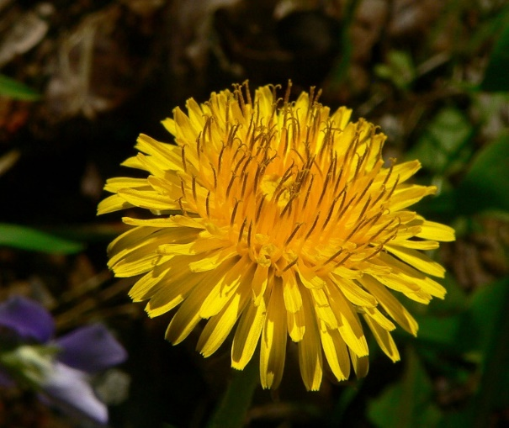The term dandelion is from the French term "dent de lion," which means lion's tooth. The common name for the plant was inspired by the jagged edges of the plant's leaves, resembling the teeth of a lion.

Is there a plant in this world more maligned than the dandelion? This most common "weed" is native to Eurasia, but it is now naturalized to many other continents including North America. Each spring, people declare war on dandelions, but the so-called weeds have an advantage, because they easily tolerate a wide range of soil and climate conditions and offer an important food source for essential insects.

It wasn't until recently that the dandelion was declared an enemy. Until the 20th century, when manicured lawns became the norm, dandelions were just another plant in the landscape, not something to eradicate.

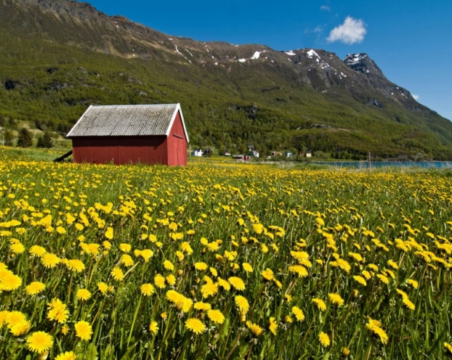Despite the war on dandelions will probably never truly be won because weeds by their very nature tend to be difficult to tame. As a newspaper columnist once wrote, "A weed is a plant that has mastered every survival skill except for learning how to grow in rows."

**How the Dandelion Saved Norway during the First World War.**

In 1918, Norway was in trouble. World War I was raging across Europe, and although this Scandinavian backwater zealously guarded its neutrality, the conflict could not be kept entirely at bay. German submarines devastated the Norwegian merchant marine, and, thus cut off from the maritime trade that had sustained it for centuries, the country descended into a period known as ‘dyrtiden’ — literally, “the expensive time.”

On 13 January 1918, a new rationing system came into effect. It limited the purchase and consumption of sugar, coffee, grain, and flour. For Norwegians, who even today subsist in great part on bread and coffee, the situation was dire. Enter the dandelion. Taraxacum officinale grows abundantly and enthusiastically here, and with enough time and tenacity you could use it to supplement your official rations.

One roadblock to dandelion consumption was mental. Newspapers of the time described dandelions as excellent food for pigs and “one of the best things that one can offer to rabbits,” which were easy to raise and recommended as an additional source of protein if only one could feed them for free. To admit that the situation had grown so desperate that one was reduced to eating livestock feed must have smarted. The dandelion’s reputation as a hard-to-kill weed also contributed to the prevailing negative attitude towards the plant.

As was written in the magazine Hjemmenes Vel: “In this time of food shortages, I am amazed that housewives…do not even attempt to make anything from dandelions. “But dandelions aren’t food!” they will say; and while they may not be as nutritious as bread or potatoes, they are health itself.”

The introduction of ration cards seems to have spurred people to reevaluate their prejudices. While ads for dandelion coffee had appeared as early as 1917, the substance only really took off when rationing forced people to seek alternatives to real coffee. Aftenposten, one of Oslo’s most respected newspapers, published an article about the “helping hand” extended by “this fiendish weed” just a week after rationing began. It included a taste test:

Dandelion coffee looks exactly like regular coffee, with a warm brown tone. Somewhat different opinions were expressed by the select group in which it, with added cream, was tasted. “I like it as much as ordinary coffee” — “No, I couldn’t say so, but if one doesn’t have any coffee beans, then it serves very well” — “It has a slightly different taste, a sweet aftertaste, but it’s not unpleasant” “I think it tastes fresh and good.”

Dandelion coffee cost half the price of real coffee and was not subject to rationing, so you could drink as much of it as you desired (though cream became so scarce that it became necessary to either drink it black or use ersatz cream made from milk, eggs, sugar, and potato flour). Aftenposten also reported that a new factory for dandelion coffee would soon be up and running: “It will require deliveries of 4000 kg of dandelion roots every day. That’s a lot of coffee. And there will be many fewer dandelions in the fields.”

Assuming that you had no money but plenty of time, you could make dandelion coffee at home. The ladies’ magazine Urd detailed the method in its April 1918 issue:

Autumn is the best time to harvest the roots, preferably when the ground has been dampened after rain. …after rinsing, brush or scrape the roots and dry them with a rough cloth. If they are to be used as ersatz coffee, they should be cut into small pieces, dried, roasted, and ground. When making “coffee” from dandelion alone, only half a teaspoon of the powder suffices for each cup of water.

In their attempts to convince Norwegians of the benefits of dandelion, the press neglected to mention that the plant is a diuretic. While dandelion coffee was said to be “an excellent remedy for insomnia,” that effect may have been dampened — no pun intended — by the necessity of getting up to relieve oneself multiple times during the night. A friend who made dandelion coffee from scratch minced no words when I asked her about her experience: “I was up most of that night peeing and I got so little sleep that I needed a nap the next day.”

While the bitterness of dandelion roots usefully mimicked the taste of coffee, this characteristic was less than desirable in other forms of food. Urd recommended boiling the roots in two 15-minute stages in order to draw out the bitterness. Afterwards, they could pureed for use in bread and other baked goods; “in baking, one can save a great deal of flour by using dandelion mash.”

If you had enough wheat flour, you needed only to take equivalent weights of dandelion mash and flour and follow the usual bread-baking procedure. Since dandelion mash did not rise well, this recipe required slightly more yeast than regular bread. In terms of taste, chervil was said to be an “excellent” addition.

Later, as wheat became scarcer, other flours took its place. One recipe for dandelion bread contains 500 grams of dandelion mash and 750 grams of rye flour. Despite its name, it was not actually bread-like. The instructions specify that the dough should be shaped into small flat rounds, which probably produced a cracker similar to rye crispbreads (knekkebrød). Another alternative bread contained graham flour, oat flour, and dandelion mash. This dough was to be mixed and kneaded “like regular bread” and then shaped into buns. Meanwhile, a recipe for dandelion fritters contained no grain flour at all. They consisted of dandelion mash with half a teaspoon of ground almonds, a teaspoon of sugar, and an egg.

Summer is the season for making jam, but this task becomes very difficult without sugar. At least two books were published in the spring/summer of 1918 with recipes to preserve fruits and berries with as little sugar as possible. If you hadn’t scrupulously saved your sugar rations, however, you could derive sugar from dandelions. (You would probably also be well-served by no little ambition in the kitchen as well as a total lack of fear.)

While dandelions served their purpose during the war, they were abandoned as soon as real coffee, flour, and sugar became readily available again. Dandelion coffee made a brief comeback during World War II; as a flour substitute, however, it was superseded by fish flour made from dried cod.

Yet despite major increases in food prices in Norway during the summer of 2022, the flower known here as “lion’s tooth” has not yet made it on to the menu. Hopefully a dandelion diet is not in our immediate future; but if it is, at least we will know exactly how to prepare them.

**After the First World War.**

In 1931, Soviet scientists were on the hunt for a natural source of rubber that would help the USSR become self-sufficient in key materials.

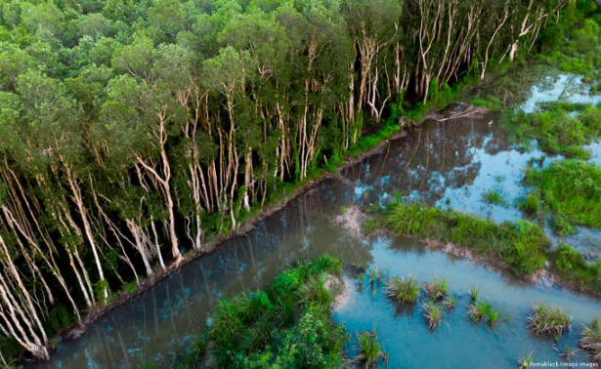They scoured the vast and various territories of the Soviet Union and tested over 1,000 different species looking for an alternative to the South American rubber tree, Hevea brasiliensi. Eventually, on the steppes of Kazakhstan, they found one. Once the war was over and supplies returned to normal, these countries — including, ultimately, the Soviets — switched back to Hevea tree rubber because it was cheaper. By 1941, the Russian dandelion, Taraxacum koksaghyz, supplied 30% of the USSR's rubber.

Overall, 65% of rubber consumed worldwide is derived from fossil fuels. This synthetic rubber is cheaper and more hardwearing than its natural counterpart. But natural rubber disperses heat better and has better grip, which is why tyres are made with a mix of both.

Today, 90% of natural rubber comes from Havea plantations in Southeast Asia, which have been linked to deforestation. And there are commercial as well as environmental reasons the tire industry would like to find an alternative.

**The Second World War.**

When the Japanese cut off most of the world’s supply of natural rubber, and by 1942 controlled some 90% of the worlds natural rubber production with the United States using about 50% of this production. The United States Forest Service and the Bureau of Plant Industry initiated an emergency rubber project to explore the potential of growing rubber within the continental United States.

From 1942-1944, the Department of Agriculture conducted a program of field-scale production and research at various locations with conditions suitable for growing Russian dandelions. Vermont was one of the 23 test sites.

**The dandelion goes to war.**

There’s an old saying that necessity is the mother of invention. That sentiment was definitely the case during World War II, a massive global conflict that presented the United States with a variety of tactical and logistical challenges. At every turn Americans seemed to need more of everything—more supplies, bigger bombs, faster airplanes, better medical treatments, and more precise communications. In response, scientists, technicians, and inventors supplied a steady stream of new products that helped make victory possible. Many of these innovations transformed the very nature of warfare for future generations and also had a significant impact on the lives of civilians as well.

Some of the new inventions helped the United States find the strategic goods necessary for fighting the war. Rubber, for example, was a vital material that was needed in enormous quantities. Building a military airplane required about 1,000 pounds of rubber, a tank needed about 2,000 pounds, and a battleship required about 75 tons. In addition, each person in the military received about 32 pounds of rubber footwear, clothing, and equipment. Normally, the rubber for these items would have come from the latex produced by millions of rubber trees growing mainly in the Dutch East Indies (present-day Indonesia) and the Malay Peninsula. In 1942, however, Japan seized both of these regions, effectively cutting off the US supply of natural rubber.

**Synthetic rubber production, ca. 1940.**

**(Image: Library of Congress, LC-USW33-028402-C.)**

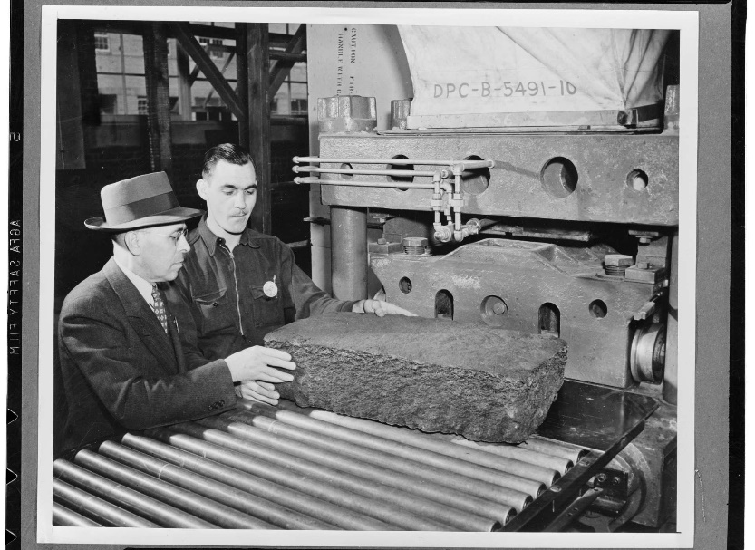The government had to act fast, and on a huge scale. Scientists had experimented with synthetic rubber as early as the 19th century, but large-scale production had never taken off in the United States. With wartime demand for rubber high and the supply of natural rubber drying up, President Franklin Delano Roosevelt’s administration invested $700 million in 51 new plants designed to make synthetic rubber from petroleum byproducts. Businesses like Firestone, Goodyear, Goodrich, and US Rubber Company, which had all been working on different formulas for synthetic rubber, agreed to share patents and scientific information with one another so that they could help solve the nation’s rubber crisis. By 1944, synthetic rubber plants were producing around 800,000 tons of material annually for the war effort.

Other WWII innovations like specialized boats, vehicles, and aircraft emerged from the military’s need to tackle lots of diverse terrain and tactical situations on battlefields all over the world. In 1940, for example, the US Army set out to modernize its transportation equipment in case the nation should be drawn into the war. Army officials called on American automakers to submit designs for a new “general purpose” military vehicle that could operate in a wide range of environments. Such a vehicle had to be light—no more than 1,300 pounds—yet it had to be able to carry at least three fully armed soldiers and a large machine gun. It also had to be able to climb a 45-degree slope fully loaded and make it through water up to 18 inches deep.

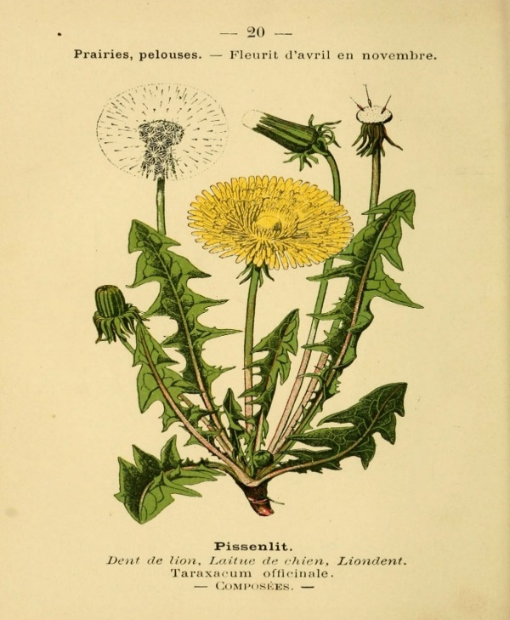Three companies built prototypes—the Ford Motor Company, Willys-Overland, and the American Bantam Car Company. Bantam’s prototype arrived first, and the other models ended up borrowing elements of its design. To make sure enough of these vehicles would be available for the war, the Army awarded production contracts to all three companies, with Ford and Willys making the majority. Soon, the United States was at war and these vehicles, which quickly received the nickname “jeep,” were carrying Allied troops around battle zones all over the globe.

An illustration from Bibliothèque de poche du naturaliste, published in 1894. Courtesy of Biodiversity Heritage Library/Woods Hole Marine Biological Laboratory of the Woods Hole Oceanographic Institution (MBLWHOI Library).

A single military airplane could use a half ton of rubber. Tanks used a ton and battleships used 75 tons. Even forces personnel used 32 pounds of rubber all associated with some form of their equipment and you could rightly assume that an army without access to natural or synthetic rubber was unlikely to be victorious.

It is noted that from 1922, the British had placed export restrictions and increased the price of rubber whilst the Germans, Americans and Russians began searching for alternatives.

The Germans were the third largest consumers of natural rubber and having experienced difficulties during the First World War due to shortages of rubber, they went on to develop Methyl Rubber which worked for a time but was expensive and soft. So soft, that vehicles equipped with tyres of Methyl Rubber had to be jacked-up when not in use. By 1930, they had developed a better synthetic rubber, Buna S: which they used throughout World War II.

**An American prisoner of war's story.**

“We were picking dandelions on the lawn there and we would boil them up,” Henry T. Chamberlain remembered. During the Great Depression, Chamberlain’s mother lost her job and couldn’t pay rent. The family moved to the grounds of the Nebraska Territory capitol building (now Omaha Central High School). “There were a million people living on that lawn,” Chamberlain said. “They all were in the same boat.”

With little money, he learned from his new neighbours about survival. After watching others rooting around in the lawn, the young man learned that dandelion flowers were free food. In addition to boiling them, “sometimes we went over to a park where the dandelions were prolific and we would pick the dandelions and wash them off and eat them green,” Chamberlain said.

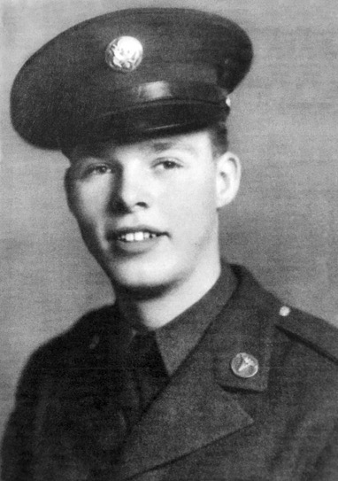Under President Franklin D. Roosevelt’s New Deal, the nation’s economy slowly began to rebuild, and Chamberlain’s dandelion-eating days seemed to be over. On his 18th birthday, in 1940, he enlisted in the army. Though he was a crack shot, and his first sergeant wanted him on the rifle team, Chamberlain said he wanted to help people—not shoot them—and trained first as a medic, then later as a surgical technician.

**U.S. Army medic Henry T. Chamberlain, around the 1940s. Photo courtesy of Rebecca Chamberlain.**

After completing his training, Chamberlain was transferred to the Philippines. By December 1941, Japanese planes bombed points in Manila and Chamberlain found himself on the front lines of Bataan serving as a combat medic.

In late January 1942, as Chamberlain transported a group of wounded men south to a hospital behind the front lines, he ran into a colonel who knew him. “He asked me where’d I been so I told him, and he said ‘well, I’ll tell you what. I badly need surgical technicians here, so you aren’t going back,’" Chamberlain said, with great thanks.

Chamberlain stayed at the hospital after American and Filipino forces surrendered on Bataan on April 9, bearing witness to horrors that took a grisly toll on the Filipino and American troops. The movement of American and Filipino prisoners of war from the Bataan peninsula, which became legendary for its brutality, was forever known thereafter as the Bataan Death March.

Under Japanese control, Chamberlain found himself at Cabanatuan Prison Number 1 assigned as a medic in a hut adjacent to the camp hospital known as the Z, or “Zero” Ward. Here prisoners too weak to stand were sent to die. Without any medicines to treat the ill, often sheer kindness and willpower became the deciding factor between life and death. Beginning in mid-June, cases of diphtheria appeared daily in the camp hospital. As a child, Chamberlain had contracted diphtheria and survived the illness. He volunteered to be a medic in the diphtheria ward because, as he explained, “first of all, I had had it and I thought I was immune from it, and secondly it was a way to get away from the Japanese and the labours they were putting us through.”

In the prisons there was no medicine to treat the sick, and the ill prisoners were missing key nutrients. Recalling the situation over 75 years later, Chamberlain observed how “there was a whole profusion of dandelions, so I told the guys ‘let the things blossom and we’ll pick the seeds, and don’t pull them up, just pull the leaves off them and eat them that way.’

And that’s what they did, they ate them green, and I think that saved a lot of lives there because we were not getting any green stuff at all and we were not getting any protein.”

After considerable deaths from malaria, dysentery, and diphtheria, the Japanese guards at last began providing medicines to the prisoners at Cabanatuan in August 1942, albeit too little too late. From June through December 1942, 2,556 American prisoners of war had died at Cabanatuan.

Chamberlain’s humble dandelion garden adjacent to his diphtheria ward went unnoticed by the Japanese guards, who feared nearing the darkened building that housed the sick and dying. He continued to work in the diphtheria wards in the Cabanatuan prison camp throughout the remainder of 1942 and into 1944.

As for the dandelions, “What few dandelions there were we fed to the sick guys in the sick bay,” he said. “I think it may have kept them going, I’m not sure, but that’s the only vitamins they got. Whatever protein was in them, that’s what they got.” Malnutrition was dangerous at Cabanatuan. “One of my friends died in my arms,” Chamberlain said, "He would not eat the rice. They were so full of maggots, rice maggots. I think for every grain of rice there was a rice maggot. One of our doctors said, ‘you just as well eat them fellas because that’s all the protein you’re gonna get.’

That’s the way that was, but my friend would not eat those things. He said, ‘people were not meant to eat worms,’ so he died in my arms, mostly from starvation.” Chamberlain’s friend remains interred at Cabanatuan, having asked that he be buried there, to “let these people know what we did for him,” with his grave marked “known but to god.”

In October 1944, the Imperial Japanese Army shipped Chamberlain and approximately 1,100 prisoners out of the Philippines to work as forced labourers. Before leaving Cabanatuan, Chamberlain made sure his dandelions came with him. Throughout his time at Cabanatuan, he “let the seeds grow and when I left there I had picked a whole bunch of seeds and put them in various places in what was left of my uniform, in pockets and things. The Japanese guards never suspected them.” After labouring in Formosa (present-day Taiwan), Chamberlain arrived in Moji, Japan, in January 1945 and was moved to Hosokura to a lead and zinc mine owned by the Mitsubishi Mining Corporation.

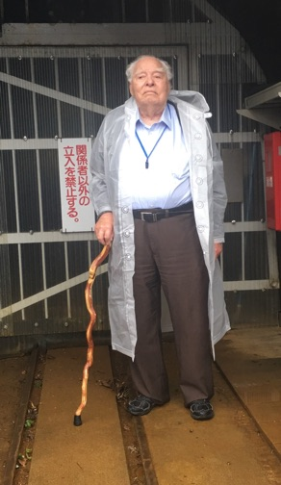At Hosokura, Chamberlain served as a medic for his fellow prisoners in Sendai #3-B Prisoner of War Camp. Chamberlain worked with one doctor to take care of all the 284 American and British prisoners. “Taking care of them didn’t mean much because we were not given any medicine, we were given very little food. If you were sick they put you on half rations because you wouldn’t work, and so that’s the way it was,” he said.

“We never saw any dandelions up there, so I planted the seeds and boy, I’m sure they got lots of dandelions up there now,” Chamberlain said with a chuckle. The dandelions again provided critical nourishment to the sick and dying, a humble weed turned heavenly manna.

In 2017 Chamberlain returned to Japan to visit the former Hosokura lead and zinc mine where he was held for almost a year as a forced laborer. Photo courtesy of Rebecca Chamberlain.

As the war closed in on the Japanese home island, Chamberlain too found himself working in the zinc and lead mines. The gruelling work of loading ore into carts and pushing them out of the mine strained all the prisoners, with food and water barely available on any occasion. At least 15 prisoners died at the camp, mostly from malnutrition. Relief for the Hosokura prisoners arrived on September 12, 1945, when American forces reached the camp and accepted the surrender of the Japanese guards.

Thereafter, Chamberlain would not need to tend any dandelions. He chose to remain in the military, transferred to the new United States Air Force, and retired after 28 years as a Senior Master Sergeant and a trained paramedic.

**UVM Experiments with Rubber Plants**

This is one of three photos of a local World War II Victory Garden taken by Burlington photographer L. L. McAllister that show a group of women in a field. The photos immediately led to questions. Where were the photos taken? Who were the women in uniform? Why were they working in what looked like a field of planted dandelions?

In this photo, a UVM agronomist displays a full-grown dandelion plant–including roots–with a label that reads, “Taraxacum-kok-saghyz/Russian Rubber-Bearing Plants, 65 Days From Planting.” At that time, UVM’s Agricultural Experiment Station generally undertook projects designed to solve problems related to Vermont conditions, but during World War II , the Experiment Station worked on projects to help the war effort. One of those projects was a study of the potential yield of seed and rubber from a Russian dandelion, Taraxacum-kok-saghyz.

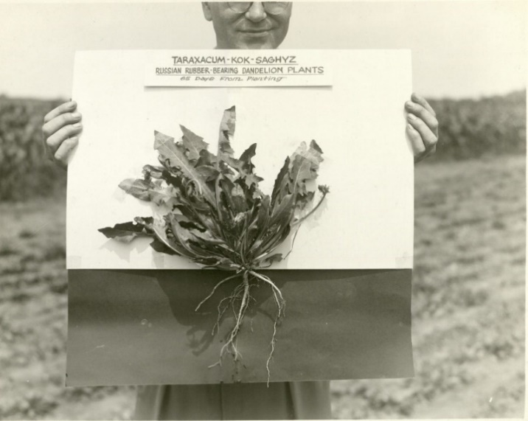Under the direction of agronomists Paul Miller and H. L. Smith, one acre of the Russian dandelion seed was planted at the UVM Farm, then located off East Avenue in Burlington. A major challenge to growing the dandelion was the need to keep the plants free from weeds. With farm labour at a shortage, the Experiment Station turned to volunteers. On July 27, 1942, the Burlington Free Press included an article headlined “Women’s Volunteer Drivers Corps Gives Up Sun. Comforts To Weed Taraxacum-kok-saghyz.” Thirty-five members of the Drivers Corps gathered on a Sunday to weed, thin and transplant the dandelions. The article is illustrated with the L.L. McAllister photographs.

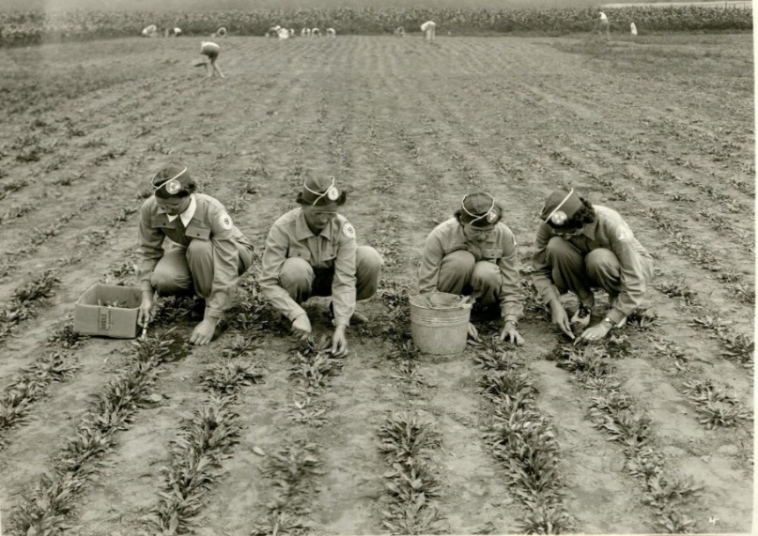Mrs. Gerald E. Prescott, the leader of the Burlington unit of the Volunteer Drivers Corp, and platoon leaders Mrs. Esther I. Adler, Miss Barbara Mitchell, and Mrs. Thomas Loudon directed the weeding.

The Extension Service continued the trial the following summer. In August 1943, the Burlington Free Press reported that almost a ton of roots were harvested and sent to a research laboratory in Philadelphia for analysis. Unfortunately, the analysis revealed that the Burlington harvest contained mostly rogue dandelions that yielded little or no rubber.

**Developing the dandelion.**

Over recent years, projects in both Europe and the US have been taking a fresh shot at making dandelion rubber commercially viable. Among them is Taraxagum, a collaboration between Continental Tires and the Fraunhofer Institute of Molecular Biology and Applied Ecology in Aachen, Germany.

"Continental Tires tested the performance of the material and said that it was brilliant — in some cases better than Hevea rubber," said Dirk Prüfer, a plant biotechnologist on the Taraxagum team.

Both Continental and competitor Apollo Tyres have used dandelion rubber to manufacture bike tyres, and Continental reports "promising" tests on dandelion truck tyres.

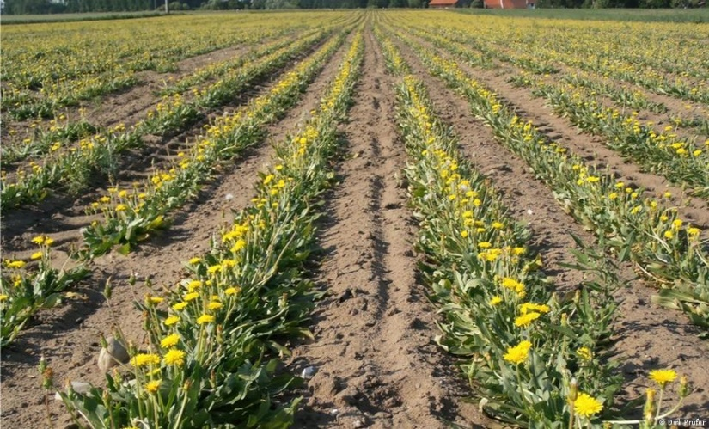Apollo was part of the EU-funded DRIVE4EU consortium, a project that ran from 2014 to 2018 and worked on developing the entire production chain for dandelion rubber, starting with cultivation. Unlike the rubber tree, the Russian dandelion thrives in temperate climates.

"We cultivated the dandelion in Belgium, the Netherlands and Kazakhstan," said Ingrid van der Meer, coordinator of DRIVE4EU, adding that other researchers had previously cultivated the crop in Sweden, Germany and the United States.

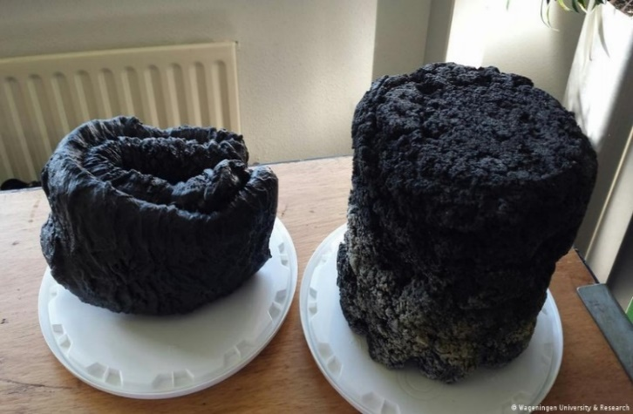The Russian dandelion can also be grown on relatively poor soils, meaning it doesn't have to compete with agriculture. Prüfer said his team was researching whether brownfield land — former industrial sites that may be heavily polluted — might even be suitable.

**... and the rubber produced from them**

Once the dandelions are harvested "hot-water extraction" is used to separate out the rubber. "The roots are chopped up mechanically and water is added," van der Meer explained. "It has to be heated up, but no large volumes of chemicals are needed. This is in contrast to Hevea rubber extraction, which requires the use of organic solvents, resulting in chemical waste that poses an environmental hazard if not disposed of properly.

"Rubber farmers need to survive, so they would simply produce other crops," he said, adding that rubber plantations in China and Thailand have already been replaced with crops like palm oil or bananas.

When a passenger jet touches down, the rubber that cushions the landing comes from trees grown in Asia. This is the same rubber found at the business end of your car tyres and in thousands of other products because natural rubber from trees is still far superior to synthetic rubber in how it absorbs energy and bounces back.

However, the EU currently imports all of its natural rubber and there are concerns that the trees in Southeast Asia, which accounts for more than 90 % of our supply, can be vulnerable to diseases. One of the answers is for Europe to grow its own rubber, not as trees, but as flowers that are a familiar sight along roadsides – **dandelions**.

**Norman Bambridge**

**Basildon Borough Heritage Society**

**26 April 2024.**