**LOCHNAGAR CRATER**

Early attempts at mining by the British on the Western Front commenced in late 1914 in the soft clay and sandy soils of Flanders. Mining at La Boisselle was in chalk, much harder and requiring different techniques.

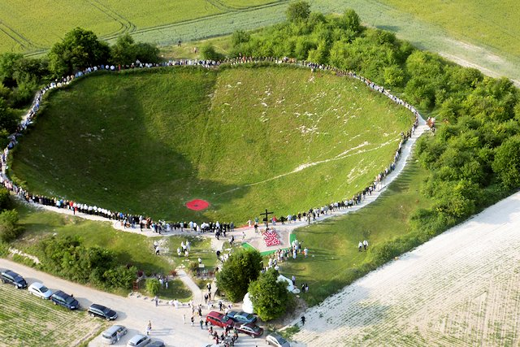The British took over the Somme area from the French during July and August 1915. On 24 July, 174 Tunnelling Company moved to the Somme front and established headquarters at Bray, taking over some 66 shafts at Carnoy, Fricourt, Maricourt and La Boisselle. Prior to the takeover, La Boisselle had been the scene of much mining activity and underground fighting. No-mans-land just southwest of La Boisselle was very narrow, at one point no more than about 50 yards (46 metres) and had become pockmarked by many chalk craters. The French and German forces were constantly mining and countermining, and the area became known as the Glory Hole.

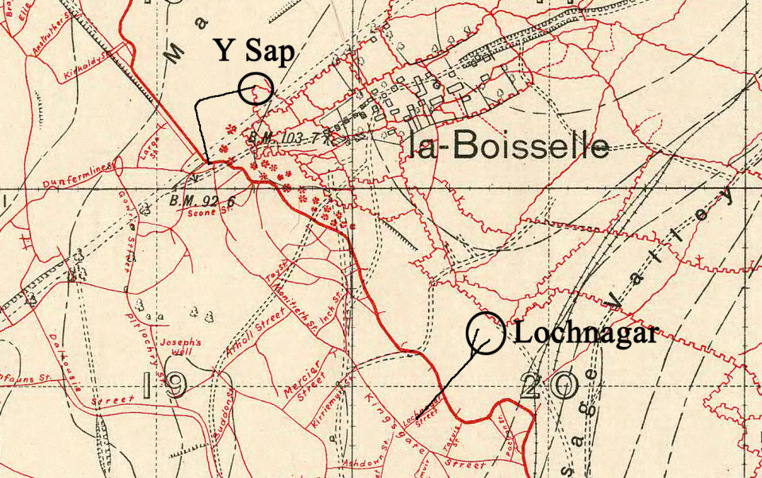

Nothing changed when the British took over, the underground war continued with offensive mining designed to destroy enemy strong points, and defensive mining to destroy enemy tunnels. Depths of tunnels ranged from 30 feet (9 metres) down to the deepest at 120 feet (36 metres). Around La Boisselle the Germans had dug defensive transversal tunnels at a depth of about 80 feet (24 metres), parallel to the front line.

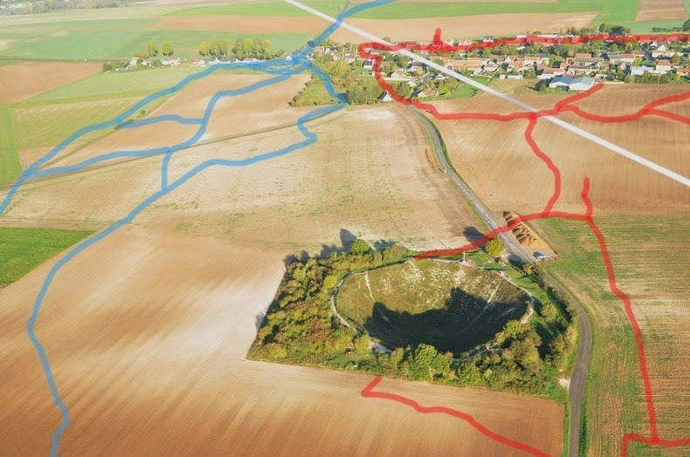

Tunnelling was a dangerous business, each side doing its best to detect and destroy enemy tunnels. On 4 February 1916, two officers and 16 men were killed, either being burnt or gassed when the Germans detonated a camouflet (a small explosive charge big enough to destroy enemy workings but not big enough to break the surface).

Captain Richardson wanted to test the then very new listening device, the Geophone to see how accurate it was in pinpointing the direction from which sounds of enemy mining were coming. He had a three level mine system starting from Inch Street, La Boisselle, the deepest being just above the water level at around 100 feet (30 metres).

Lieutenant Edward Lyall went to the deepest level and made deliberate noises, whilst Captain Richardson and Second Lieutenant Arthur Latham went into the middle level to see if they could use the Geophone to ascertain the direction from which Lieutenant Lyall's noise was coming from. It was during this experiment that the Germans blew the large and unexpected camouflet that killed the 18 men.

For the 1st July 1916 attack two large mines were planned, one to the north of La Boisselle (Y Sap), one to the south (Lochnagar). Both were 'overcharged' which means that more explosive was used than necessary to just break the surface, so large rims were formed from the disturbed ground.

The tunnel for the Y sap mine started in the British front line near where it crossed the Albert to Bapume road, but because of German underground defences it could not be dug in a straight line. About 500 yards (457 metres) were dug into no-mans-land before it turned right for about another 500 yards (457 metres). Some 40,000 lbs (18,144 kilograms) of ammonal (high explosive) was placed in the chamber beneath Y sap.

In addition to the two large mines, the Glory hole was also attacked with two smaller charges of 8,000 lbs (3,628 kilograms) each, designed to wreck German tunnels. Communication tunnels were also dug for use immediately after the first attack but were little used.

To try to ensure that the enemy did not find out about them, a high level of secrecy was maintained about their existence.

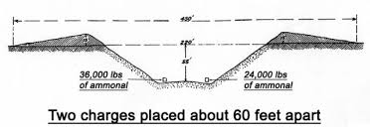

So secret that Incredibly the attacking infantry did not know about them. An exception to this was the Russian sap from Kerriemuir Street which was eventually connected to Lochnagar Crater and the German front line. For some time this was the only means of crossing Sausage Valley. A battalion of the 19th Division and the 9th Cheshire’s passed through it, and it was used to evacuate the wounded.

**Lochnagar Mine**

The tunnel for the Lochnagar mine was started on 11 November 1915 by 185 Tunnelling Company, but was completed by 179 Tunnelling Company who took over in March 1916.

The shaft for the Lochnagar mine was sunk in the communication trench called Lochnagar Street. It was probably the first deep incline shaft, meaning that it was not sunk vertically but sloped down with an incline of between 1:2 and 1:3, to a depth of some 95 feet (29 metres). It was begun some 300 feet (91 metres) behind the British front line and 900 feet (274 metres) from the German front line.

In the Lochnagar inclined shaft, at about 50 feet (15 metres) below ground level, a gallery was driven towards the German strong point called the Schwaben Höhe. The final depth of the explosives chambers was about 52 feet (16 metres).

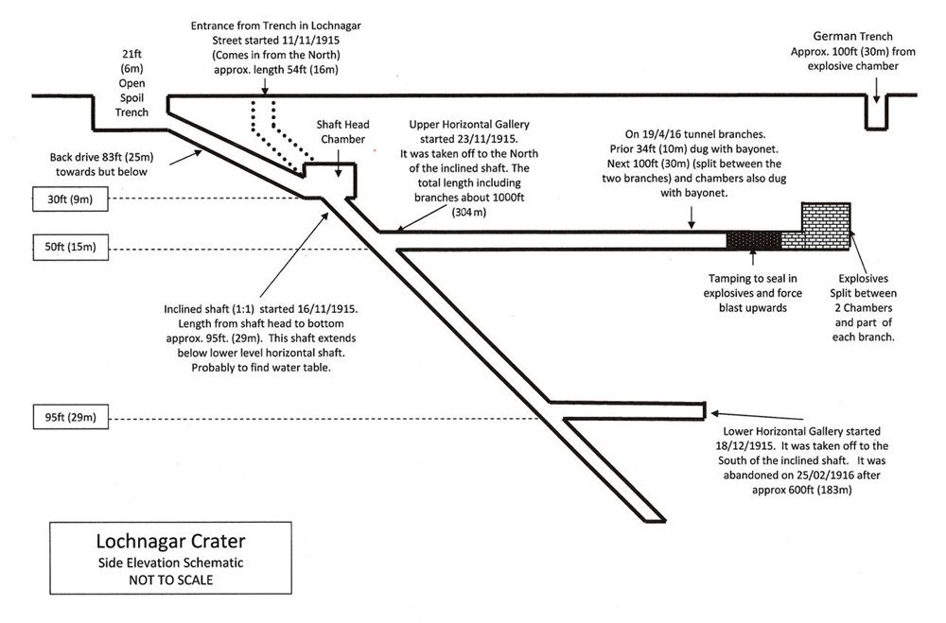

As the tunnellers drew nearer to the German line, progress was slowed due to the need to be as silent as possible whilst working. Pickaxes could not be used, progress was made by lumps of chalk being prized out with a bayonet, caught without hitting the ground and passed back for disposal. Miners worked without boots, walking on sandbags, and talking was limited to a whisper. They could hear the Germans who were working below them in a transversal tunnel.

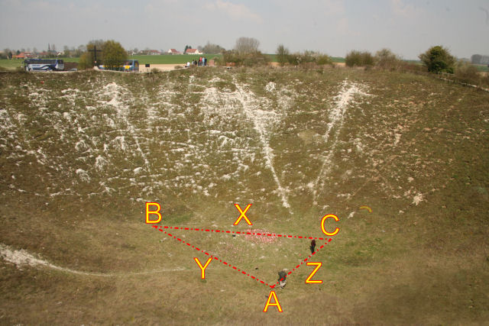

*Position of the charges and tunnels under the crater  
A = Point were the tunnel from Lochnagar Street divides into two branches  
B = Explosive Chamber holding larger charge of 36,000lbs (16,330kg) of high explosive  
C = Explosive Chamber holding the smaller charge of 24,000lbs (10,886kg) of high explosive  
X = Distance between the two explosive chambers 60ft (18m)  
Y = Longer branch of the tunnel 60ft (18m) long  
Z = Shorter branch of the tunnel 40ft (12m) long*

Captain James Young pressed the plunger at 0728 (local time), the two charges combined formed one massive crater. Spoil from the blast spread over a diameter of 450 feet (137 metres), obliterating some 300 to 400 feet (110 to 122 metres) of German line and nine dug outs.

How many were killed? Who knows! However, it is said that it covered nine deep dug-outs, each capable of holding an officer and 35 men, a total of nine officers and 315 men.

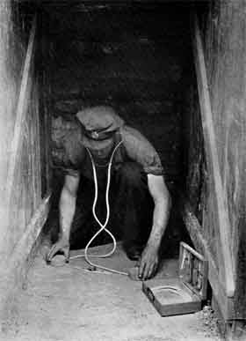 A Sapper using a Geophone listening device.

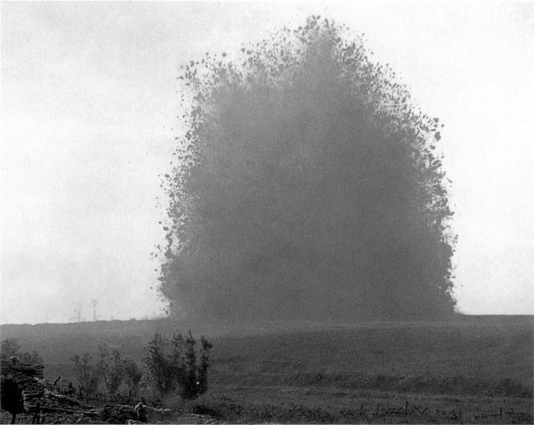

The crater left now measures some 300 feet (91 metres) across the highest point of the rim and 70 feet (21 metres) deep from the top of the rim. The Lochnagar crater is the biggest man-made crater made by a single aggressive explosion.

However, another mine, at St. Eloi which was blown on 7 June 1917 contained 95,600 lbs (43,363 kilograms) of ammonal, some 35,600 lbs (16,150 kilograms) more than at Lochnagar, but the resulting crater was smaller.

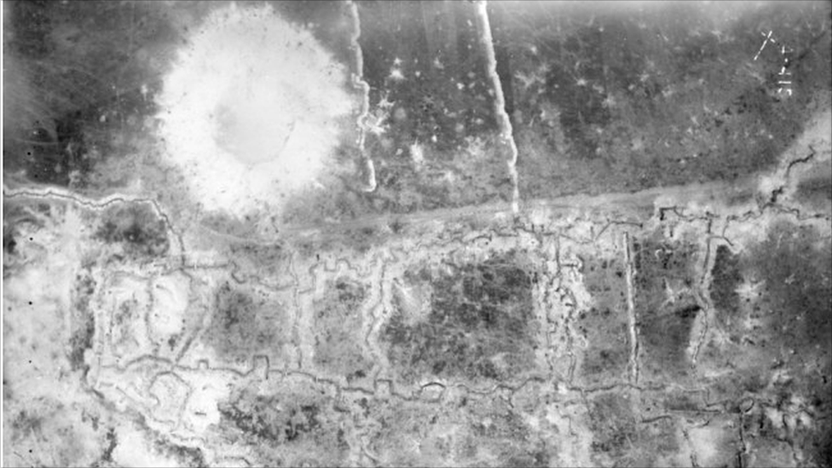

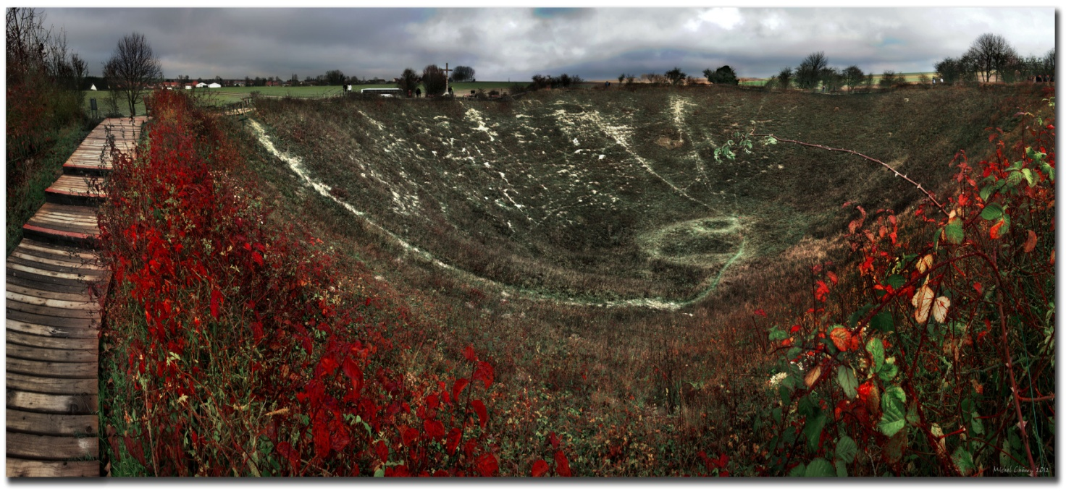

Basildon Borough Heritage Society

December 2024.